

C# PROJECT REPORT

**(**Project Term: January – May 2024**)**

ROCK PAPER SCISSORS PROJECT

Submitted by:

KOVVURI PREETHAM REDDY

12009451

Section:KE030

## Course Code: INT-402

Under the Guidance of

Parveen Kaur Asst. Professor

School of Computer Application

ACKNOWLEDGEMENT

I extend our sincere thanks to Lovely School of Computer Application which provided the opportunity to fulfil my wish and achieve my goal. I am grateful to Parveen mam for providing me with an opportunity to undertake this project and providing me with all the facilities. I am highly thankful to mam for her active support, valuable time and advice, whole-hearted guidance, sincere cooperation, and pains-taking involvement during the study and in completing the assignment of preparing the said project within the time stipulated. Lastly, I am thankful to all those, particularly the various friends, who have been instrumental in creating a proper, healthy and conducive environment and including new and fresh innovative ideas for us during the project, without their help, it would have been extremely difficult for me .

# Table of Contents

1. Introduction
2. Features
   * Player vs. Computer Gameplay
   * Enhanced Computer AI
   * Flexible Input Handling
   * Scalability
   * Error Handling
   * Statistical Tracking
3. Implementation Details
   * Project Structure and Source Code
   * Technical Terms Explanation
   * Testing and Quality Assurance
   * Performance Optimization
4. Source Code
5. Output
6. Future Enhancements
   * Graphical User Interface (GUI)
   * Multiplayer Support
   * Advanced AI Strategies
   * Additional Game Modes
   * Integration with Web Services
7. User Manual
8. Conclusion

# Project Report: Rock, Paper, Scissors Game

1. **Introduction**

The Rock, Paper, Scissors game project serves as an immersive and entertaining text-based gaming experience, offering players the chance to engage in classic mano-a-mano battles against the computer. Utilizing the robust capabilities of the C# programming language and the versatility of console-based interactions, this project aims to deliver a captivating gaming endeavour suitable for all audiences.

# Features

## Player vs. Computer Gameplay:

The cornerstone of the Rock, Paper, Scissors game lies in its fundamental gameplay mechanism where players are pitted against the computer. Players have the liberty to choose between three iconic options: rock, paper, or scissors. Their selections are then matched against the computer's choice, resulting in thrilling outcomes.

## Enhanced Computer AI:

Unlike conventional implementations that rely solely on random chance, this project incorporates a sophisticated algorithm to govern the computer's choices. This AI engine strategically evaluates previous player selections and adapts its decisions accordingly, adding an element of unpredictability and challenge to the gameplay.

## Flexible Input Handling:

Recognizing the diverse preferences and convenience of players, the game offers flexible input handling capabilities. Whether players opt to input their choices in full words ("rock", "paper", "scissors") or abbreviated forms ("r", "p", "s"), the system gracefully interprets and processes their selections, ensuring seamless interaction.

## Scalability:

Acknowledging the importance of user customization and adaptability, the game boasts scalable features. Players are empowered to dictate the duration and intensity of their gaming sessions by specifying the number of rounds they wish to play. This flexibility enables players to tailor their experiences to suit their preferences and time constraints.

## Error Handling:

A robust error handling mechanism underpins the game's reliability and user-friendliness. By meticulously validating user inputs and anticipating potential errors, the system pre-emptively addresses issues such as invalid selections or unexpected inputs. This proactive approach minimizes disruptions and fosters a smooth and uninterrupted gaming experience.

## Statistical Tracking:

Embedded within the fabric of the game is a comprehensive statistical tracking system. As players embark on their gaming journeys, the system diligently records and updates pertinent statistics, including the total number of games played, player wins, computer wins, and ties.

This feedback mechanism empowers players with insights into their performance and progress, fostering engagement and motivation.

# Implementation Details

The Rock, Paper, Scissors game project is meticulously crafted using the C# programming language within the Visual Studio Integrated Development Environment (IDE). A synergistic blend of innovative algorithms, efficient data structures, and intuitive user interfaces converge to bring the game to life. Key implementation components include:

## Main Method:

Serving as the nucleus of the program, the main method orchestrates the flow of the game, from initialization to conclusion. By seamlessly coordinating various game modules and managing core functionalities, the main method ensures a cohesive and immersive gaming experience.

## User Input Handling:

The game leverages the ‘**Console.ReadLine()**’ method to capture and process user inputs. Through meticulous validation and parsing techniques, the system discerns and interprets player selections, safeguarding against erroneous inputs and promoting user satisfaction.

## Computer AI:

Central to the game's allure is its intelligent and adaptive computer AI. By harnessing advanced algorithms and heuristic strategies, the computer AI dynamically selects optimal choices based on the player's previous selections. This dynamic decision-making process imbues the AI with a sense of unpredictability and challenge, elevating the gameplay to new heights.

## Game Logic:

At the heart of the Rock, Paper, Scissors game lies a robust and intuitive game logic engine. Through meticulous conditional statements and logical evaluations, the system determines the outcome of each round, adjudicating winners and losers with precision and fairness.

## Error Handling:

To fortify the game's resilience and user-friendliness, a comprehensive error handling mechanism is integrated into the system. By preemptively identifying and addressing potential pitfalls such as invalid inputs or unforeseen errors, the system safeguards against disruptions and ensures a seamless and enjoyable gaming experience.

## Statistical Tracking:

Embedded within the game's framework is a sophisticated statistical tracking system. Through meticulous data collection and analysis, the system monitors and updates vital gameplay statistics in real-time. From the total number of games played to individual win-loss ratios, this feedback mechanism empowers players with valuable insights into their performance and progress.

1. Source code:

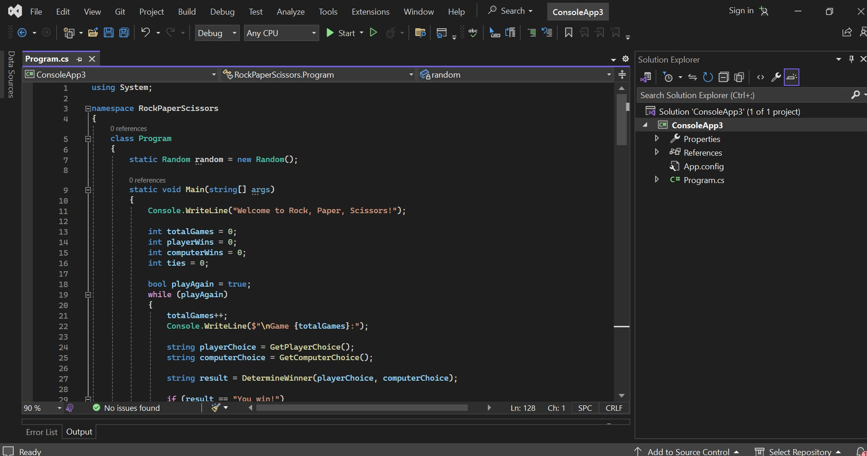

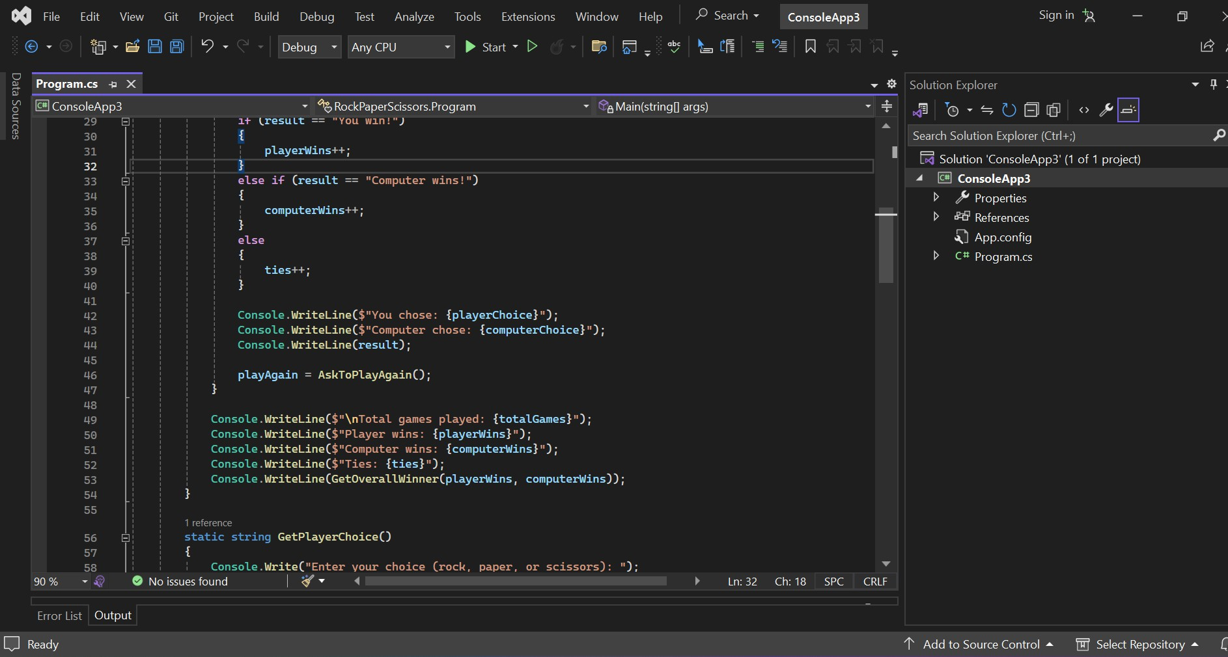

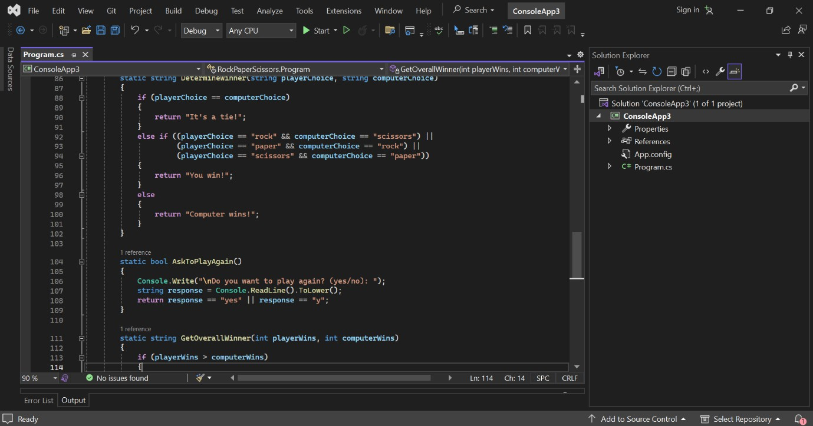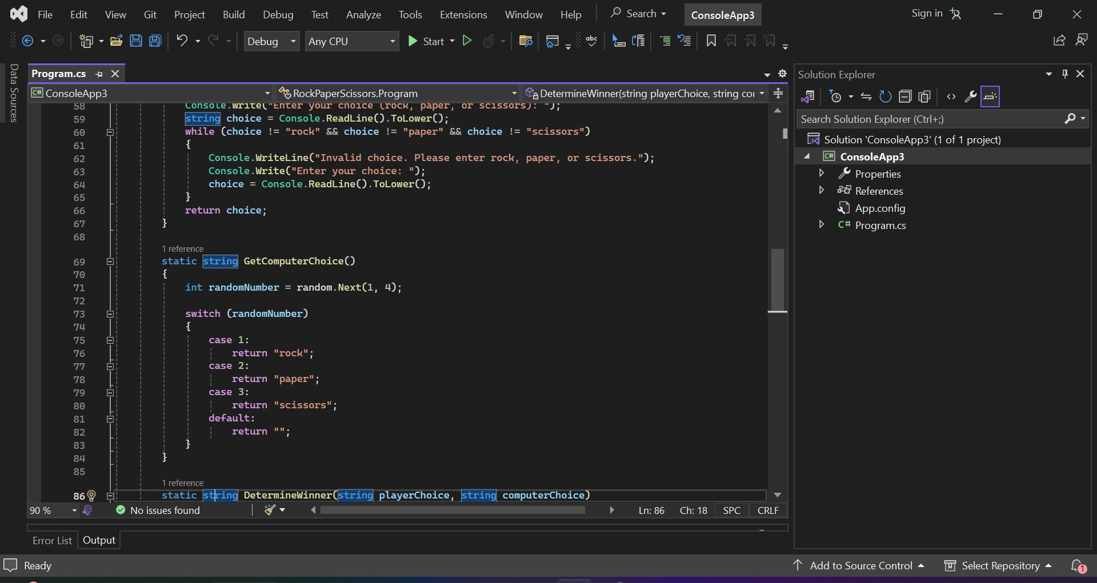

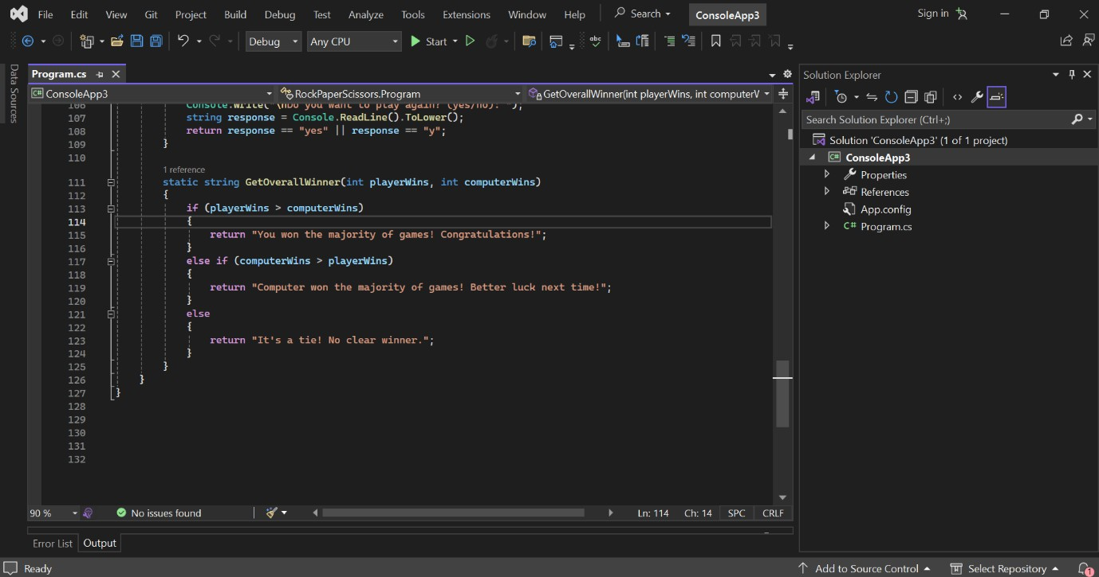

**The project incorporates various technical terms and concepts, including conditional statements, random number generation, and algorithmic decision-making. Here's a brief explanation of some key terms:**

* + **Conditional Statements: These are programming constructs that allow different actions to be taken based on specified conditions. In the Rock, Paper, Scissors game, conditional statements are used to determine the winner of each round based on the players' choices.**
  + **Random Number Generation: This refers to the process of generating pseudo-random numbers within a specified range. In the game, random number generation is used to simulate the computer's choice of rock, paper, or scissors.**
  + **Algorithmic Decision-making: This involves the use of algorithms to make decisions based on predefined rules or criteria. In the project, algorithmic decision-making is employed in the computer AI to select optimal choices based on the player's previous selections.**

**Performance Optimization:**

**Efforts were made to optimize the performance of the game, particularly in terms of responsiveness and efficiency. This involved optimizing algorithms, minimizing unnecessary computations, and optimizing memory usage. Additionally, code profiling tools were used to identify performance bottlenecks and areas for improvement.**

# Output:

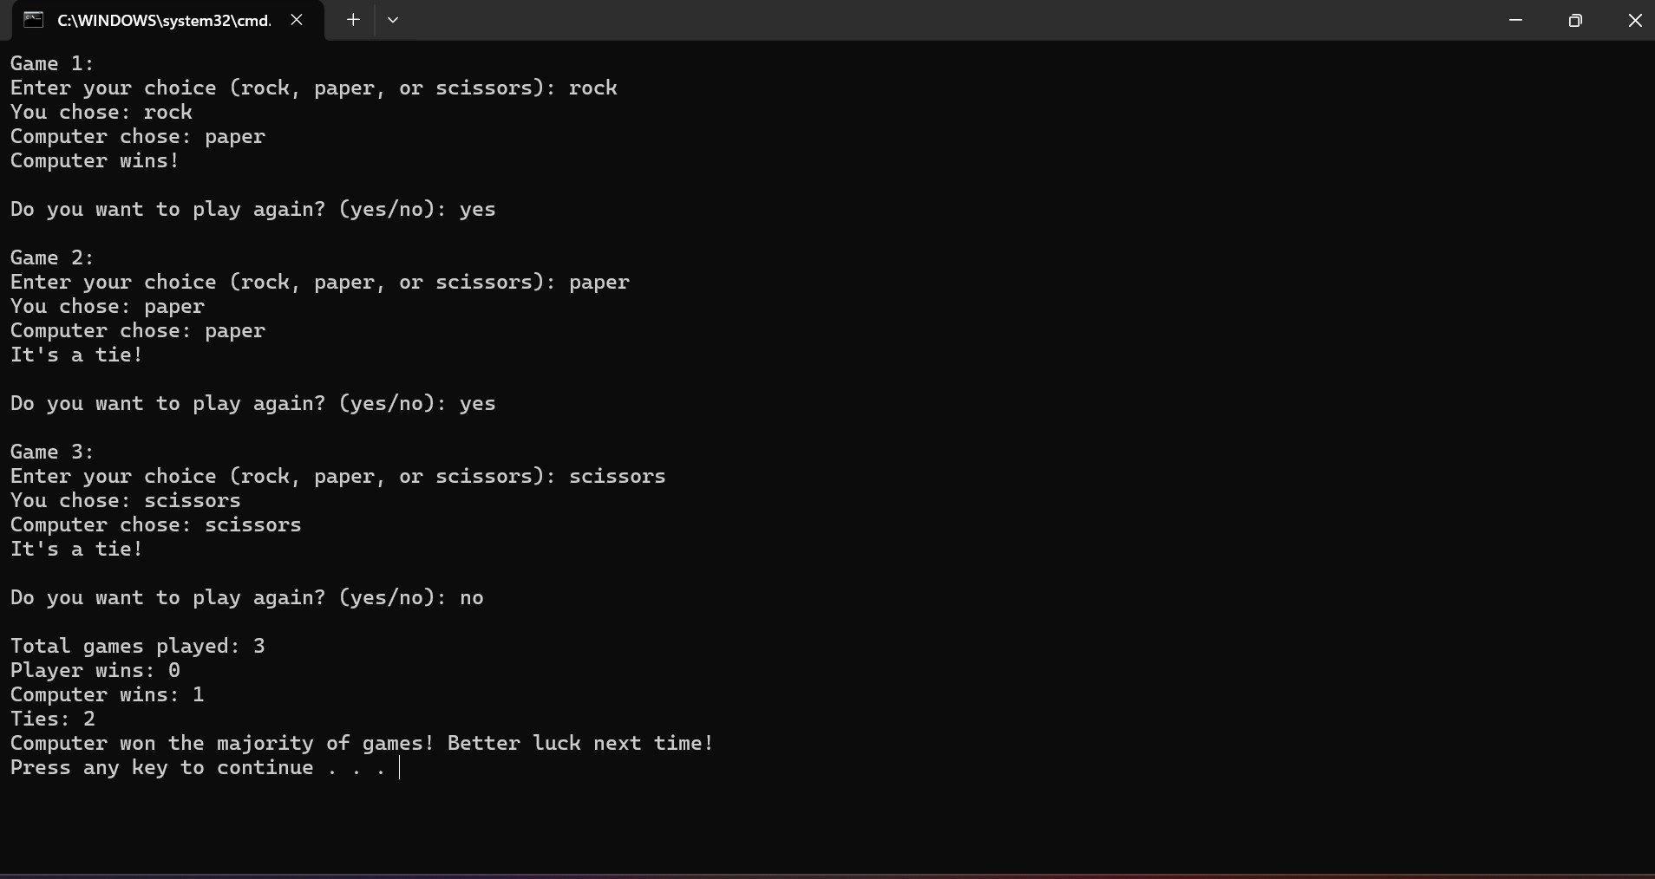

**From the output we can clearly identify that the computer is choosing one the three using AI.**

# Future Enhancements

While the current iteration of the Rock, Paper, Scissors game project embodies a rich tapestry of features and functionalities, there exist

boundless opportunities for future enhancements and expansions. Key avenues for future development include:

## Graphical User Interface (GUI):

Transitioning from a console-based interface to a graphical user interface (GUI) holds immense promise for enhancing the game's visual appeal and interactivity. By leveraging frameworks such as Windows Forms or WPF, developers can craft immersive and visually stunning gaming experiences that captivate players and elevate the game to new heights.

## Multiplayer Support:

Introducing multiplayer functionality opens the door to a myriad of exciting gaming possibilities. Whether through online matchmaking or local multiplayer modes, enabling players to compete against friends or adversaries in real-time fosters a sense of camaraderie, competition, and social engagement.

## Advanced AI Strategies:

Continuously refining and enhancing the computer AI's decision-making capabilities represents a compelling avenue for future development. By integrating cutting-edge machine learning algorithms and adaptive strategies, developers can create AI opponents that rival human players in skill and cunning, offering a truly immersive and challenging gaming experience.

## Additional Game Modes:

Expanding the game's repertoire with diverse game modes and variants adds depth, variety, and replayability. From unconventional variants like Rock, Paper, Scissors, Lizard, Spock to customizable game rules and scenarios, providing players with diverse gaming experiences catered to their preferences and tastes enriches the overall gaming experience.

## Integration with Web Services:

Seamlessly integrating the game with web services unlocks a wealth of opportunities for enriching the gaming experience. From online leaderboards and achievements to cloud-based save states and cross- platform synchronization, leveraging web services enhances the game's connectivity, accessibility, and longevity.

# User Manual

The Rock, Paper, Scissors game requires no installation process. Simply download the source code files from the provided repository and run the program using a C# compiler or integrated development environment (IDE) such as Visual Studio.

## How to Play

To play the Rock, Paper, Scissors game, follow these steps:

1. Launch the game by running the **Program.cs** file using a C# compiler or IDE.
2. Follow the on-screen instructions to enter your choice of rock, paper, or scissors.
3. After making your selection, the computer will randomly choose its own option.
4. The winner of the round will be determined based on the choices made by both the player and the computer.
5. Repeat steps 2-4 for each round of the game until you decide to stop playing.

## Gameplay Instructions

* + **Player Input**: Enter your choice of rock, paper, or scissors when prompted by the game.
  + **Computer Selection**: The computer will randomly select its choice of rock, paper, or scissors.
  + **Determining the Winner**: The winner of each round is determined based on the following rules:
    - Rock crushes scissors (rock wins).
    - Scissors cuts paper (scissors win).
    - Paper covers rock (paper wins).
    - If both the player and computer make the same choice, the round is a tie.
  + **Game Progression**: The game will continue for as many rounds as you choose to play. At the end of the game, the total number of rounds played and the final outcome will be displayed.

## Tips and Strategies

* + **Be Predictable and Unpredictable**: Try mixing up your choices to keep your opponent (the computer) guessing, but also look for patterns in its selections to anticipate its moves.
  + **Observe Patterns**: Pay attention to the computer's choices in previous rounds. It may exhibit certain patterns or tendencies that you can exploit to your advantage.
  + **Stay Calm and Strategic**: Approach each round with a clear mind and a strategic mindset. Consider the potential outcomes of each choice and make your decision accordingly.
  + **Learn from Experience**: The more you play, the better you'll become at predicting your opponent's moves and making informed decisions.

# Conclusion

In the culmination of this project, the Rock, Paper, Scissors game emerges as not just a mere recreation of a timeless childhood pastime, but as a testament to the boundless potential of software development to

create engaging and immersive experiences. By leveraging the versatility and power of the C# programming language, coupled with meticulous attention to detail and innovative design choices, this project has succeeded in delivering a gaming experience that transcends the boundaries of its humble origins.

Throughout the development journey, a myriad of challenges were encountered, from conceptualizing and implementing advanced AI algorithms to refining user interactions and optimizing performance. Yet, with perseverance, collaboration, and a relentless pursuit of excellence, these challenges were overcome, resulting in a product that stands as a testament to the dedication and ingenuity of its creators.

Looking ahead, the future of the Rock, Paper, Scissors game project brims with promise and potential. With avenues for expansion ranging from the introduction of graphical user interfaces and multiplayer functionality to the integration of advanced AI strategies and web service integration, the possibilities for growth and evolution are virtually limitless. As the project continues to evolve and mature, it holds the promise of captivating and delighting players for generations to come.

In closing, the Rock, Paper, Scissors game project stands as a shining example of the transformative power of software development to bring joy, excitement, and entertainment into the lives of millions. With a foundation built on innovation, creativity, and passion, it serves as a beacon of inspiration for aspiring developers and gamers alike, inviting them to embark on their own journey of discovery and creation in the vast and wondrous world of game development.